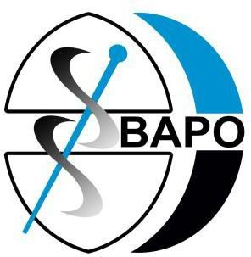

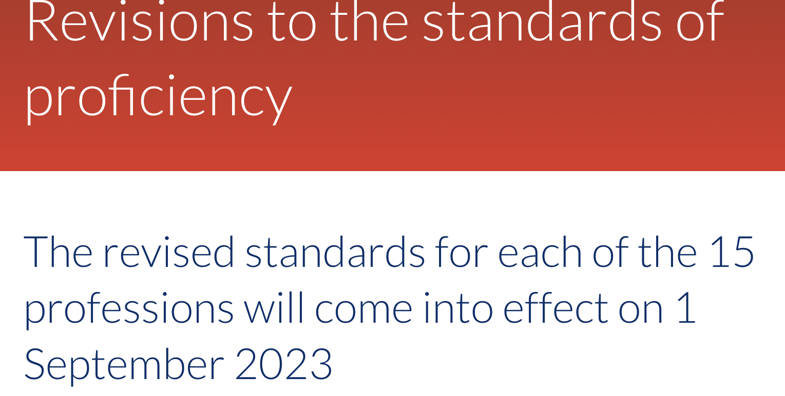
The Health and Care Professions Council (HCPC) standards of proficiency for prosthetists and orthotists

The Health and Care Professions Council’s (HCPC) standards of proficiency for prosthetists and orthotists are changing. The changes will take effect from 1st September 2023.
All registered members of the HCPC must be aware of these changes and be able to demonstrate their practice meets the new standards from this date. You can download a copy of the new standards of proficiency for prosthetists and orthotists here.
Why are the standards important?
Since 2001 the HCPC has set standards for conduct, performance, ethics, and continuing professional development (CPD) as well as proficiency for prosthetists and orthotists along with the other professions it regulates. It keeps a register of professionals known as ‘registrants’ who, by meeting these standards, are allowed to practice under a protected title in the UK. The HCPC can also investigate concerns about a registrant’s fitness to practice.
The standards are necessary to assure the safe and effective practice of prosthetists and orthotists and play an important role in protecting the public. They describe what prosthetists and orthotists must know, understand, and be able to do, both at the time they apply to join the register and at the biennial point of renewal when a percentage of prosthetists and orthotists are selected for CPD audit.
The standards are therefore essential to all practising prosthetists and orthotists because they form the baseline against which a registrant will be judged should a fitness-to-practice complaint be made against them. Failure to meet the standards could therefore result in sanctions from the HCPC, including being removed from the register.
They are also relevant to students undertaking pre-registration studies who need to be aware of the standards they will be held to when practising.

What will be different?
Following the HCPC’s consultation process, the changes move away from prosthetists and orthotists passively understanding the standards, to a requirement to actively demonstrate the standards in practice.
The updated standards of proficiency will provide more focus on the following areas:

Equality, diversity, and inclusion

Centralising role of the service-user

Promoting public health and preventing ill-health
Registrant’s mental health

Digital skills and new technologies

Leadership at all levels of practice

What should you be doing?
Start to familiarise yourself with the forthcoming changes in the standards. Each registrant has a personal responsibility and accountability to be able to demonstrate they are meeting the new standards from the 1st September 2023.
You may find it helpful to use the HCPC gap analysis tool to understand how the changes to the standards will affect you and your scope of practice:
Gap analysis tool
The HCPC advises
A registrant’s particular scope of practice may mean that they are unable to continue to demonstrate that they meet all the standards of proficiency that apply to the whole of their profession. As long as they make sure they are practising safely and effectively, within their given scope of practice, and do not practise in the areas where they are not proficient to do so, this will not be a problem.
Standards should be applied within your scope of practice. For example, if you are a prosthetist/orthotist working in a non-patient-facing role, you will not be expected to demonstrate standard 14.6 – understand and be able to apply appropriate moving and handling techniques – as this is not part of your role.
What is my employer’s responsibility?
It is your employer’s responsibility to be aware of the changes and create an environment where registrants can meet the new standards. This may include opportunities to discuss these as part of supervision, team meetings, and/or CPD opportunities to support registrants to be up and running with the standards by September.

What is BAPO doing to support its members?
Between now and the implementation of the revised standards, BAPO will be signposting members to a range of resources to help support your understanding of what the HCPC expects from practising prosthetists and orthotists. BAPO will also be running a series of articles in BAPOConnect.

HCPC support and resources
The HCPC has information pages and resources to support registrants’ understanding of the changes and has produced a table comparing the current and new standards. They are also running a series of webinars, details of which can be found on the HCPC website.

Resources
HCPC’s consultation process to develop the changes
HCPC’s changes to standards – comparison to current standards
Information and resources to support understanding of changes
HCPC webinar details

