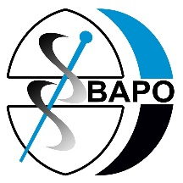
BAPO Recruiting Now!

Education and Practice Development Officer
Fixed term 15 hours per week for 24 months

This is an exciting opportunity to join our team at The British Association of Prosthetists and Orthotists and lead on education strategy development for our profession. The Education and Practice Development Officer will work within the BAPO Education Committee to support the development of education resource and content, building on clinical practice policy and delivering projects relating to prosthetic and orthotic education and professional practice. The Education and Practice Development Officer will also act as a source of advice and information on professional matters, good practice and service provision for BAPO members.
The role has been funded by collaboration between BAPO and the Orthotic Education and Training Trust (OETT). This role is part time, for two days (15 hours) a week, on a two-year fixed term contract. Subject to the success of the role the contract may be subject to renewal by negotiation.
To request full job description please email enquiries@bapo.com
For all enquiries, please contact Chair of Education Committee Lynne Rowley lynne.rowley@bapo.com
Please forward your C.V. and covering letter to enquiries@bapo.com

Closing date for applications 10 December 2021

