We currently have 2 exciting opportunities for a Principal Orthotist and a Senior Orthotist to join our established clinical team in Yorkshire!

Principal Orthotist

This is an opportunity for an experienced Orthotist to progress their career and develop operational management skills. Management experience is not required as full support and development will be provided via the Clinical Services Manager.

The successful candidate will perform the following functions:

- Professional Development of clinical staff
- Operational management of Yorkshire region, including managing sickness, annual leave, and maternity.
- Timetabling clinical staff and communication of clinical timetables to Trusts
- Co-ordinating payback sessions when cancellations occur
- Knowledge of KPI production using the Meditech software system
- Co-ordination and content of team meetings.
- Own clinical patient caseload.
- Multi-disciplinary training
- Facilitating student placement

Excellent communication skills are essential as you will be expected to develop strong working relationships with our customers, informing them of any timetable changes, cancellations and payback sessions as required. The successful candidate will be responsible for understanding the clinical environment, identifying development opportunities, and facilitating training for the clinical team. The successful candidate will not only be clinically, but also commercially aware, demonstrating the ability to balance clinical and business need. Responsibilities will also include networking with other professionals, providing in-house training presentations to raise awareness of our skills and services.

Senior Orthotist

This role will allow the successful candidate to develop orthotics practice within the Mid Yorkshire Regional Spinal Injuries Clinic, along with experience within a Paediatric MDT, treating CTEV patients, working alongside Paediatric Surgeon’s. This position will be mainly based within the Mid Yorkshire Hospital Trust (Wakefield, Pontefract, and Dewsbury) and Barnsley Hospital NHS Foundation Trust which both boast modern clinical facilities. As well as the more specialist MDT clinics the caseload will provide enjoyable challenges working with neuromuscular, diabetic and MSK patients, where whole gait analysis and biomechanical solutions will be required. CPD time will be provided for self-development and development of the service, to ensure we maximise clinical outcomes.

As part of your role you will be expected to work autonomously to assess and treat a plethora of different conditions, using the full extent of your clinical knowledge. Good communication skills are essential for the patient experience, but also to develop strong relationships with key referrers within the multi-disciplinary team.

If you care passionately about the service you deliver, act with integrity in ethical decision making and care about making a difference to patient’s lives, then Steeper would be a great career opportunity as your next clinical role. Any successful candidate will receive a competitive salary based upon experience and will qualify for our employment benefits scheme. We may also ask you to be involved in wider company initiatives such as our Best Practice, Product Evaluation and Innovation forum groups, or assisting in new product development, meaning your career with Steeper could be broader and more dynamic than your clinical role alone.

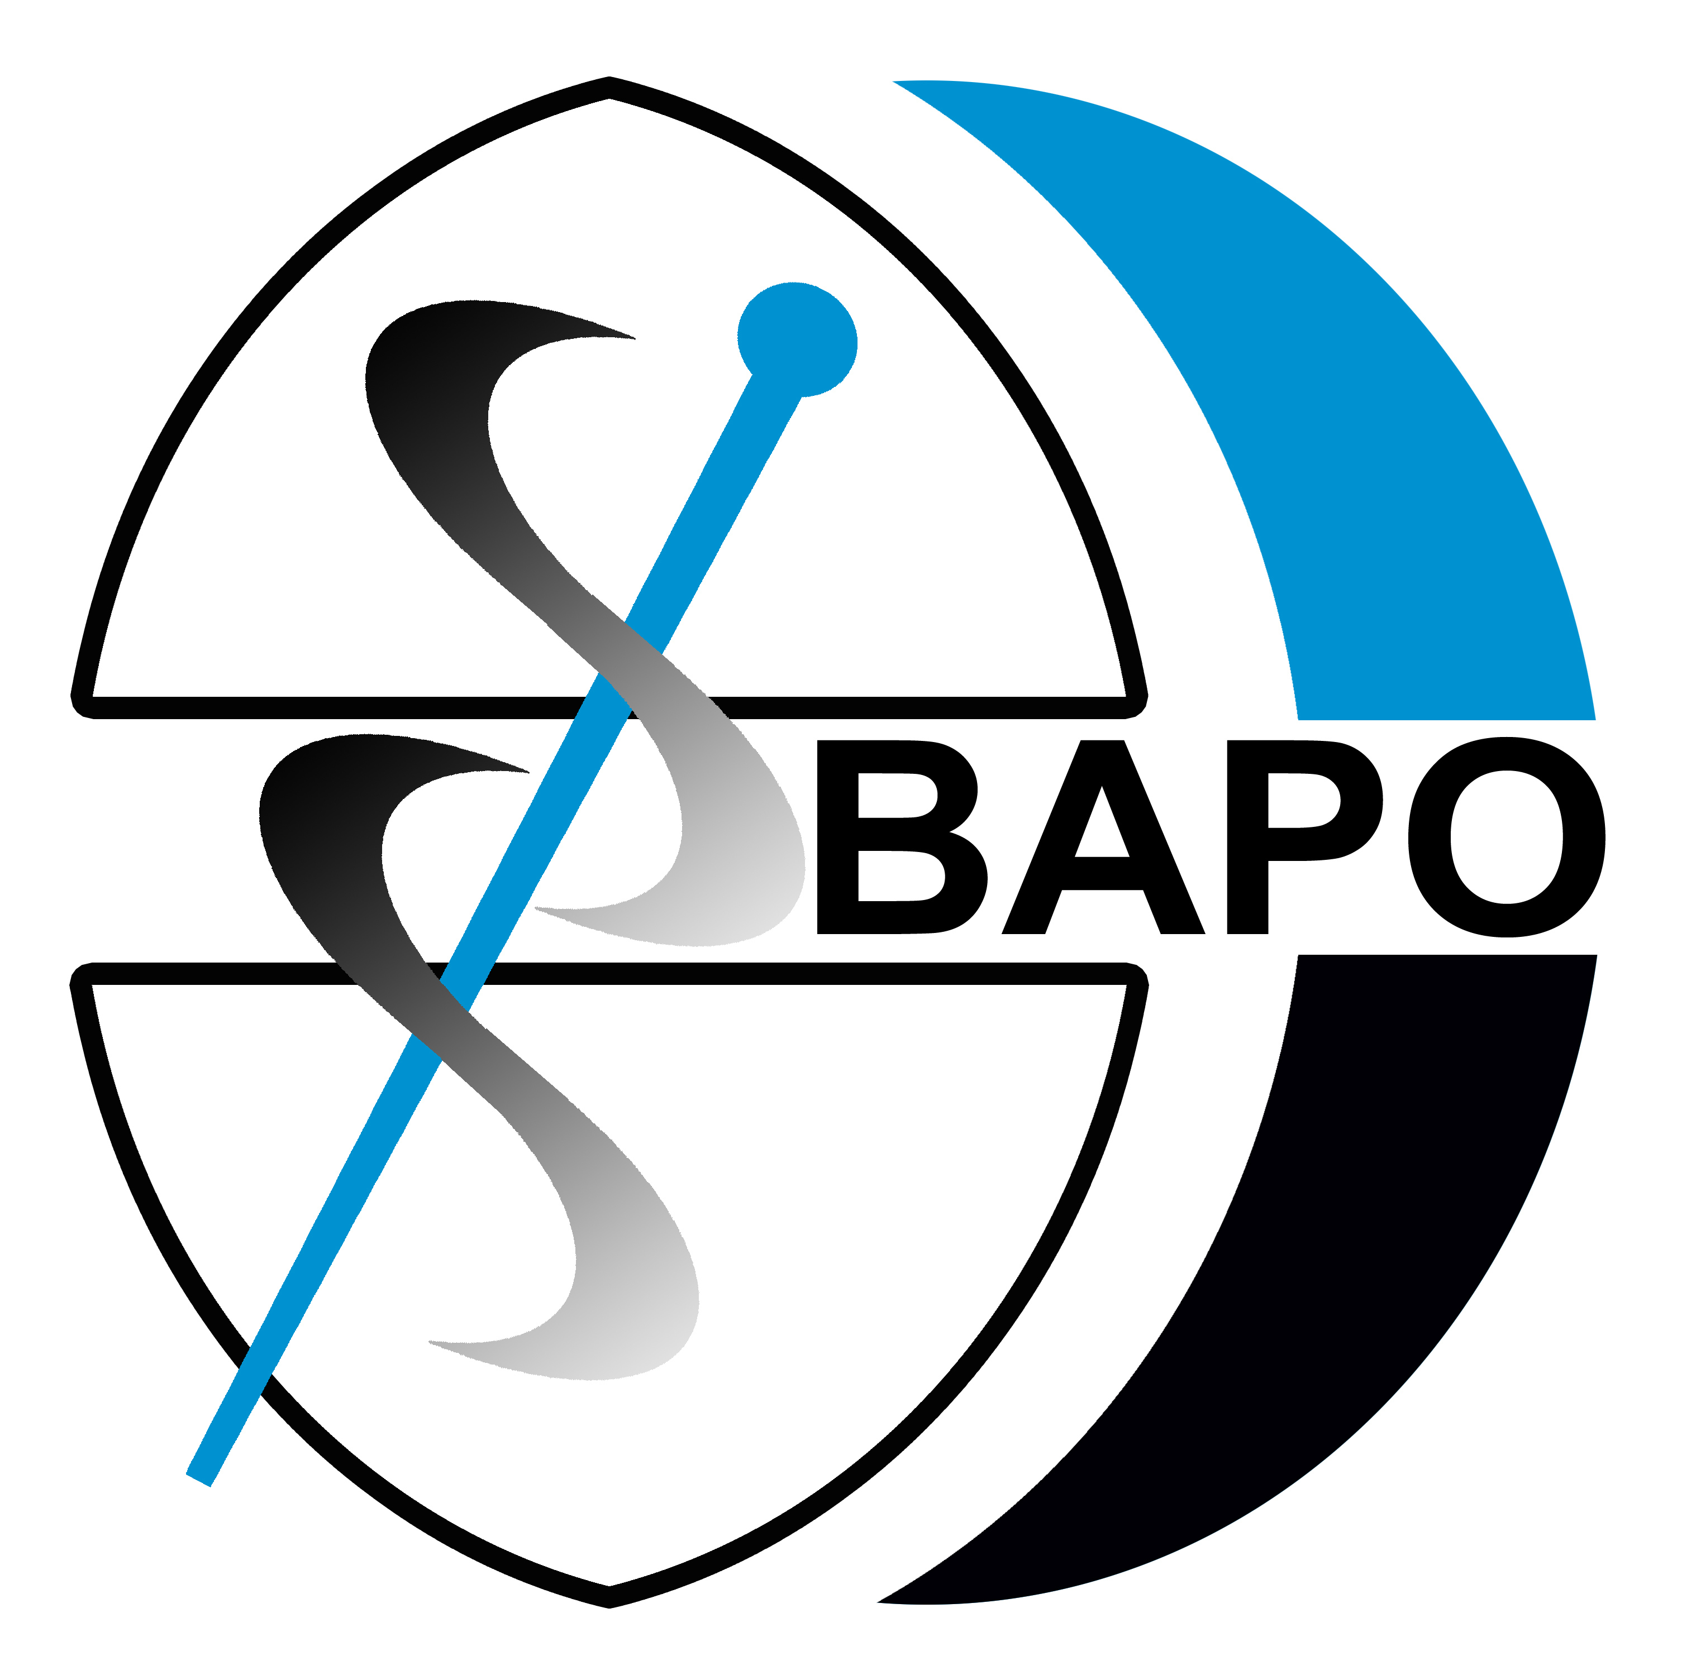
If you would like to work with the largest group of Prosthetists and Orthotists in the country, then please apply by sending your CV to hr@steepergroup.com. For further information on these exciting positions please visit our website www.steepergroup.com/careers

Applicants must be HCPC registered and preferably members of BAPO.
Closing date – 24th September 2021

