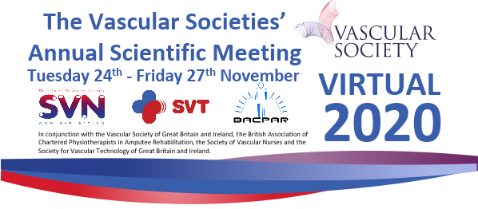

Join us for BACPAR’s first ever virtual conference!

Also, for the first time, BACPAR 2020 will be part of the

Vascular Societies Annual Scientific Meeting.

This means BACPAR delegates get access to all content from the VS, SVN and SVT programmes!

BACPAR programme – more TBC! Programme times
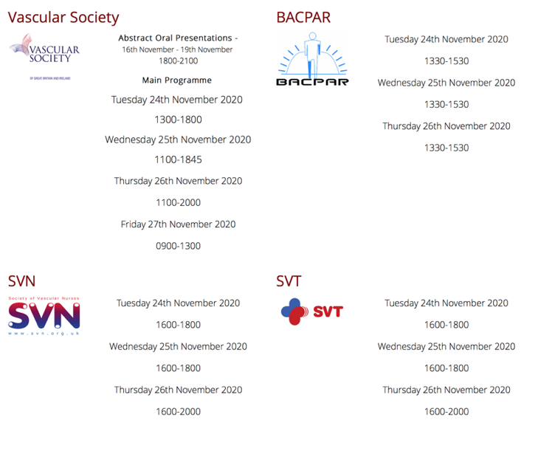

Tuesday
Evidence based Clinical Guidelines for the Physiotherapy Management of Adults with Lower Limb Prosthesis Update
Report on Major Lower Limb Amputations Due to Vascular Disease: A Multidisciplinary Approach to Surgery and Rehabilitation
10 years of Surveying the Lower Limb Amputee
Population in Scotland SPARG
Through-knee versus above-knee: rehab outcomes and experiences of the MDT

Wednesday
Use it, then lose it. Rehabilitation of staged amputations in a quadrilateral amputee with symmetrical peripheral gangrene.
BLART predicting mobility Post Amputation
Does a low score on the Montreal Cognitive Assessment (MOCA) correlate with prosthetic mobility outcomes for patients undergoing intensive inpatient amputee rehabilitation
Abstracts

Thursday
Impact of MPK Prescription on Physical Activity

The Impact of Hydraulic Foot and Ankle Provision on K3 and K4 activity users
A randomised feasibility study of a self-aligning prosthesis for older patients with vascular-related transtibial amputations: The STEPFORWARD study
People Powered Prosthetics

Was it me or the MDT?

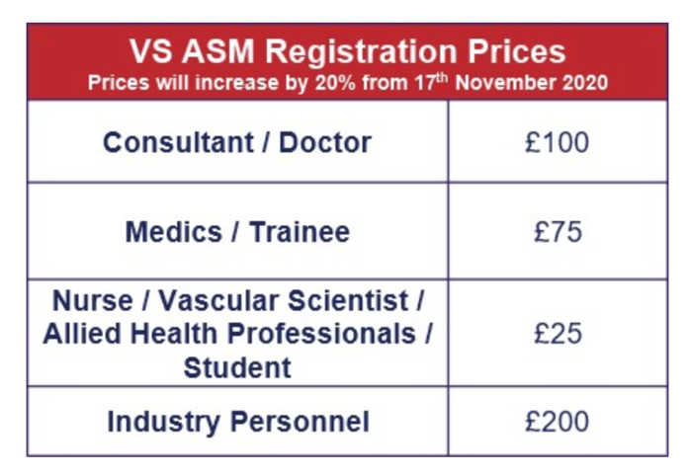

Thursday Evening Symposium
All delegates are invited to the SVN symposium with guest speaker David Nott 7-8pm.
Virtual drinks reception 6.30-7pm. Purchase a drink of your choice through smile.amazon.co.uk to donate money to the Circulation Foundation.

Go to vascularsociety.org.uk or search “VSASM 2020” to register and see the full programme

