Subscription Form
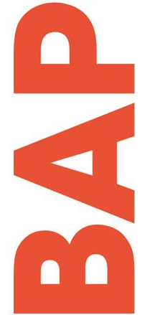
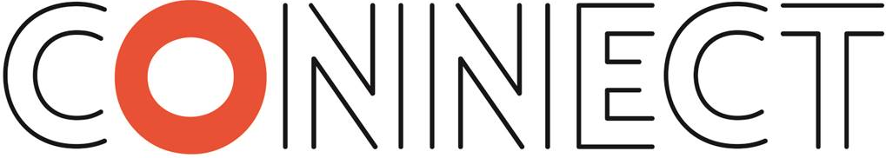

BAPOConnect is a publication distributed by BAPO three times a year to our members as part of their membership subscription. If you are a non-member or organisation and wish to receive BAPOConnect please complete and return the form below.

Address

Name of Organisation (if applicable)

Forename Mr/Mrs/Ms/Dr/Prof

Surname

Email Web Site

Telephone Mobile
Postcode

BAPOConnect yearly subscription fee:

Rate | Cost (one copy per issue)
UK | £25
Abroad | £30 (Sterling)

BAPOConnect Subscription Order Forms to be completed and returned with payment to the BAPO Secretariat, Sir James Clark Building, Abbey Mill Business Centre, Paisley, PA1 1TJ.

BACS payments for total amount to be made using the following details:

Reference: BAPOConnect + Surname

Account number: 00134707 - Sort Code: 834600

Cheques to be made payable to BAPO

The consecutive year runs from 1 January to 31 December. Mid-year Subscribers will be expected to pay the full yearly rate at date of order and will receive back-dated copies of any previous BAPOConnect issues.

An annual reminder will be issued to current subscribers before 31 December in any given year.

